Final Project: Paper

Madelyn Wolf
Information Technology, Arizona State University
IFT 320: Managing the Cloud
Professor John Lewis
December 3rd, 2025

Final Project: Paper
Applied Supercomputing Users (ASU) Inc. currently relies on a traditional physical infrastructure to support its organizational computing needs, but its legacy environment is reaching the end of its operational life and can no longer scale efficiently with the company’s growing demands. At the request of the Chief Technology Officer, the following information outlines the operational cost of moving to a cloud-based infrastructure.
Deliverables:
- 20 database (Microsoft SQL) Windows servers with 64GB of RAM and 4 CPU cores each
- 200 non-database Linux servers with 8GB of RAM and 2 CPU cores each
- 25 TB of S3 storage
- 10 TB of EBS storage
Figure 1
A table comparing the infrastructure costs with the Compute Savings Plan for the 1 Year and 3 Year Reservation Terms.
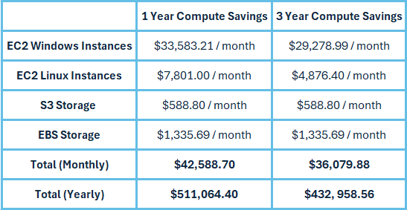
Amazon Web Services (AWS) offers a Compute Savings plan, which reduces costs by committing to a consistent amount of compute usage while maintaining flexibility (AWS, 2025b). For a one-year reservation term with a Compute Savings Plan, the total yearly expenditure is $511,064.40. For a three-year reservation term with a Compute Savings Plan, the cost reduces to a yearly expenditure of $432,958.56, which equates to $1,298,875.68 for all three years. In each plan, the 20 database instances have a Windows Server with SQL Server Enterprise operating system and an instance type of x2iedn.xlarge to accommodate the required RAM and CPU specifications. The 200 non-database instances have a Linux operating system and an instance type of t4g.large. The S3 storage is standard storage and meets the requirements provided by the CTO. The Elastic Block Store storage is a general-purpose SSD (gp3) to reduce the cost slightly and meets the requirements. Below are the calculations provided by AWS in the pricing calculator for each EC2 instance type at the two different reservation terms.
Figure 2
A screenshot of the calculations tab for the required Linux servers at a one-year Compute Savings Plan.
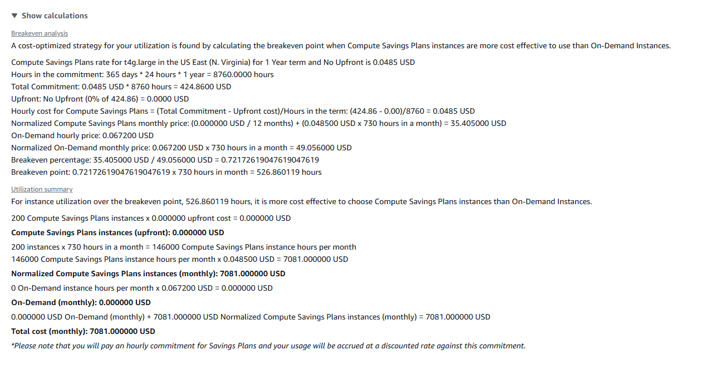
Figure 3
A screenshot of the calculations tab for the required Linux servers at a three-year Compute Savings Plan.
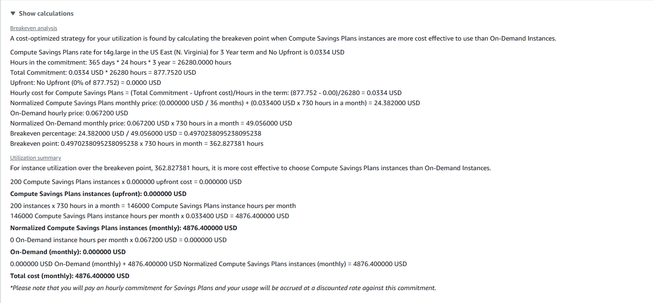
Figure 4
A screenshot of the calculations tab for the Windows servers at a one-year Compute Savings Plan.
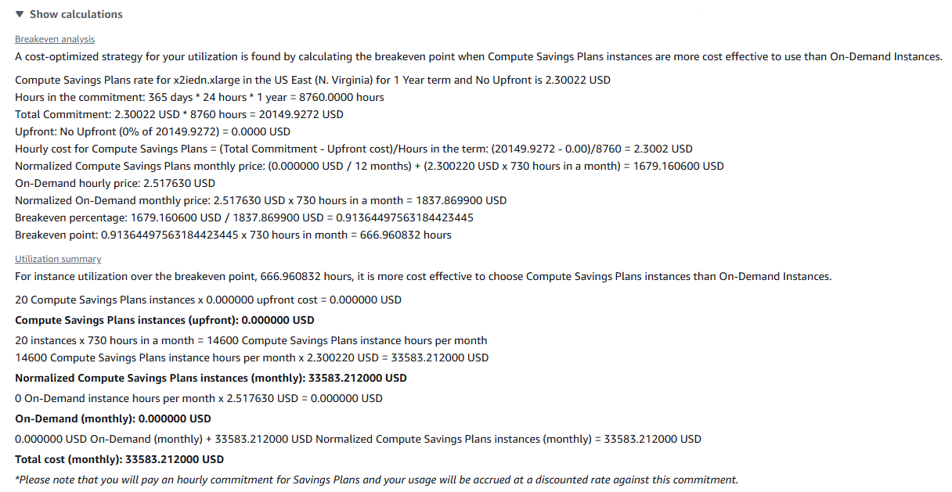
Figure 5
A screenshot of the calculations tab for the Windows servers at a three-year Compute Savings Plan.
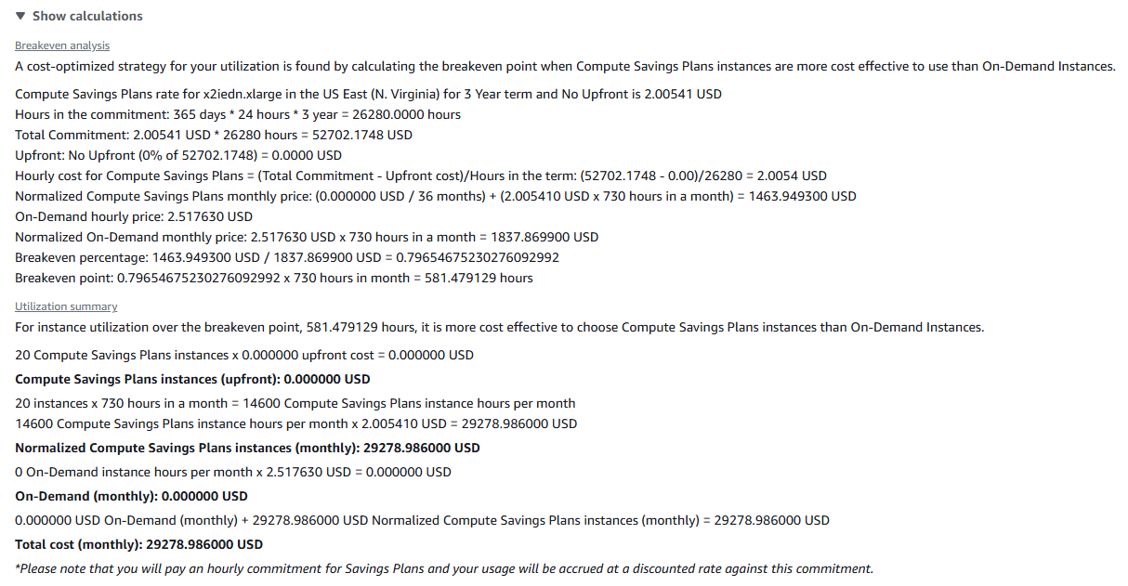
In addition to evaluating Compute Savings Plans, it is important for ASU Inc. to understand how Amazon EC2 Reserved Instances (RIs) compare from a cost-optimization standpoint.
Figure 6
A table comparing the infrastructure costs with Reserved Instances for the 1 Year and 3 Year Reservation Terms.
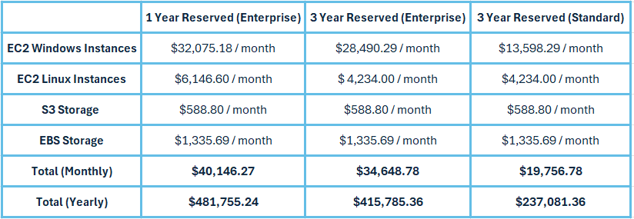
Reserved Instances trade flexibility for greater potential savings when workloads are predictable and stable. Standard RIs require committing to a specific instance family and region for a one- or three-year term, but in return, they typically deliver a larger discount than Compute Savings Plans for fixed workloads such as ASU Inc’s required infrastructure (AWS, 2024). For a one-year reservation term of RIs using SQL Server Enterprise, the total yearly expenditure is $481,755.24. Extending this to a three-year reservation reduces the yearly cost to $415,758.36, which equates to $1,247,275.08 over the full three-year period. The most substantial savings occur when the database servers are licensed with SQL Server Standard instead of Enterprise, with a yearly expenditure of $237,081.36, or $711,244.08 for the three-year period, which translates to a 43% reduction in overall expenses compared to the Enterprise configuration for Reserved Instances. Below are the calculations provided by AWS in the pricing calculator for each EC2 instance type at the two different reservation terms.
Figure 7
A screenshot of the calculations tab for the required Linux servers at a one-year reservation term for Reserved Instances.
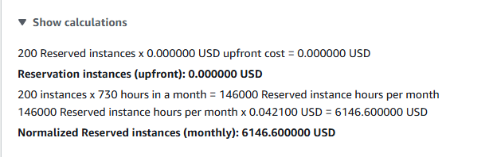
Figure 8
A screenshot of the calculations tab for the required Linux servers at a three-year reservation term for Reserved Instances.
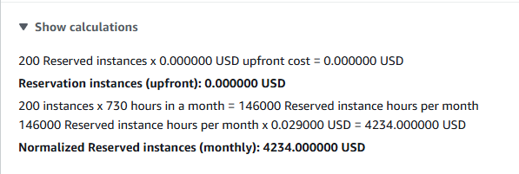
Figure 9
A screenshot of the calculations tab for the Windows SQL Server Enterprise at a one-year reservation term for Reserved Instances.
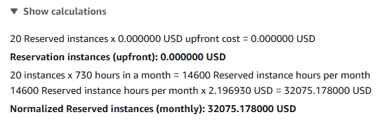
Figure 10
A screenshot of the calculations tab for the Windows SQL Server Enterprise at a three-year reservation term for Reserved Instances.
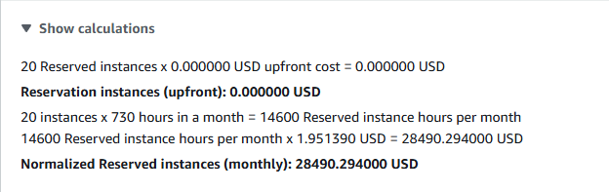
Figure 11
A screenshot of the calculations tab for the Windows SQL Server Standard at a three-year reservation term for Reserved Instances.
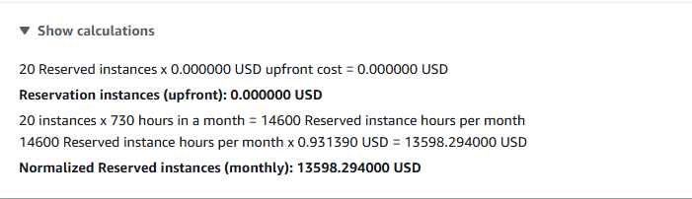
Based on the data, the most cost-effective solution for ASU Inc. is to adopt Reserved Instances for both the Windows-based database servers and the Linux application servers using a three-year reservation term. RIs provide the greatest annual savings across every component of the proposed infrastructure, lowering compute costs more effectively than Compute Savings Plans while still meeting all performance and capacity requirements. Additionally, it is recommended for the Windows Servers to use SQL Server Standard over Enterprise. Enterprise supports maximum available RAM, advanced virtualization, multi-replica failover, and near-zero downtime index maintenance (Forrester, 2024). While these features are significant, it is not necessary for ASU Inc. based on the CTO’s requirements. The infrastructure specifications fit well within the technical limits of SQL Server Standard, which supports:
- 24 cores per instance
- 128 GB of RAM
- Robust transactional performance
- Security features such as transparent database encryption (TDE) and auditing
(Microsoft Learn, 2025).

By selecting SQL Server Standard under a three-year Reserved Instance, ASU Inc. achieves the necessary database reliability and performance at a significantly lower licensing cost. RIs also provide meaningful savings for the company’s Linux-based application servers. Because these servers have consistent utilization patterns and uniform specifications, they are ideal for long-term RI commitments. The 25 TB of S3 Standard storage provides durable, highly available object storage for application assets, and because Amazon S3 storage is usage-based rather than compute-based, it does not require long-term commitments or reservations to achieve cost efficiency (AWS, 2025a). The 10 TB of EBS gp3 storage offers a balance of performance and affordability for operating system volumes, with predictable monthly costs that scale only with the amount of storage allocated. Together, the use of Reserved Instances for compute and scalable, consumption-based storage services for S3 and EBS ensures that ASU Inc.’s entire AWS infrastructure remains both technically aligned with operational needs and financially optimized for long-term sustainability.
Migrating ASU Inc. to the cloud from a physical infrastructure requires a structured and phased approach. This will ensure operational continuity, data integrity, and efficient resource utilization. The first and second phase of a cloud adoption plan includes an assessment and discovery phase and planning and design. Since the CTO has provided the infrastructure requirements, ASU Inc. can streamline these early phases by focusing on validating the suitability of the selected AWS resources, confirming that the proposed instance types and storage configurations align with workload expectations, and identifying any operational, security, or networking considerations that must be addressed before migration. Security is especially important and will require ASU Inc. to implement “updated security strategies and governance framework needed to govern cloud operations and services to ensure their long-term stability”, which can be determined through a risk assessment. (Kale, 2015).
The next step is the migration and implementation phase, where ASU Inc. can leverage the AWS Application Migration Service to replicate existing server images for the Linux servers. The AWS Database Migration Service can be used to migrate the Windows SQL servers securely and with minimal operational disruption. For the 25 TB of S3 storage, ASU Inc. can utilize AWS DataSync, which is a fully managed service that automates and accelerates the transfer of data online between on-premises storage and S3. Operating system volumes for both Windows and Linux servers can be imported using VM Import/Export service and backed up by leveraging Amazon EBS snapshots. Following the migration is the testing and validation stage, where verification of proper application functionality, database replication, and network connectivity is performed. During this phase, it is also important to validate IAM access, monitor CloudWatch configurations, and ensure the backup and snapshot workflows are operational.
Finally, in the optimization phase, ASU Inc. can employ AWS Trusted Advisor to help ensure that the cloud environment remains secure, reliable, and cost-efficient over time. Trusted Advisor provides ongoing recommendations related to cost optimization, performance improvements, security best practices, fault tolerance, and service limits (Amazon Web Services, Inc, 2025). By regularly viewing these insights, ASU Inc. can maintain efficient and well-governed cloud architecture long after the initial migration is complete. This structured migration approach ultimately enables ASU Inc. to transition smoothly from aging physical servers to a scalable and financially sustainable cloud-based infrastructure.

References
Amazon Web Services, Inc. (2025). User Guide AWS Support. In AWS Trusted Advisor. https://docs.aws.amazon.com/pdfs/awssupport/latest/user/support-ug.pdf#trusted-advisor
AWS. (2024). Amazon EC2 Reserved Instances. Amazon Web Services, Inc. https://aws.amazon.com/ec2/pricing/reserved-instances/
AWS. (2025a). Amazon S3 Pricing. Amazon Web Services, Inc. https://aws.amazon.com/s3/pricing/
AWS. (2025b). Compute Savings Plans and Reserved Instances - Savings Plans. Amazon.com. https://docs.aws.amazon.com/savingsplans/latest/userguide/sp-ris.html
Forrester, R. (2024, May 29). SQL Server Standard vs Enterprise: Which Is Best For You? Five. https://five.co/blog/sql-server-standard-vs-enterprise/
Kale, V. (2015). Guide to cloud computing for business and technology managers: From distributed computing to cloudware applications (1st ed.). CRC Press.
Microsoft Learn. (2025, May 19). Editions and Supported Features of SQL Server 2022 - SQL Server. Microsoft.com. https://learn.microsoft.com/en-us/sql/sql-server/editions-and-components-of-sql-server-2022?view=sql-server-ver17

